MACHINE LEARNING INTERNSHIP W/
ANALYST LAB AFRICA
________________________________________________________________
WEEK 6 REPORT: HYPER PARAMETER TUNING AND CROSS-VALIDATION
By Ibinabo Direh

The project builds a binary classification model to predict whether a patient has diabetes using the Pima Indians Diabetes dataset.
The goal is to edtablish a baseline Logistic Regression model, apply hyperparameter tuning via GridSearchCV with 5-fold cross-validation, and evaluate whether tuning improves performance over the baseline (using default parameter).

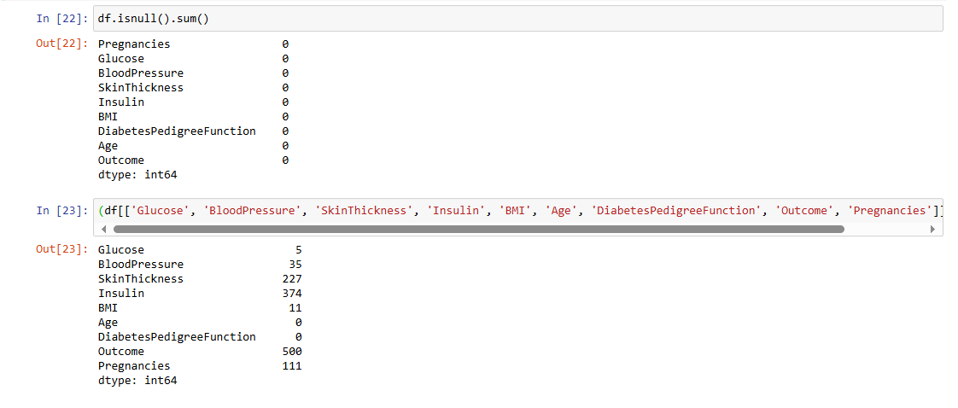
In this diabetes dataset, at first glance it would seem there were no missing values, but we find a good amount of cells with value 0. These values were treated as missing data for all other columns except Pregnancies and Outcome which are on/off indicators. In the other columns like Insulin, BloodPressure etc., 0 is an impossible value for a living human. Hence they were considered as missing values. This demonstrated to me the importance of domain knowledge.
Dropping these rows are not an option as they make up almost half of the record in the dataset and would lead to a data loss.
Filling is the better option. Whether with mean or median could only be decided after observing the nature of their distribution.

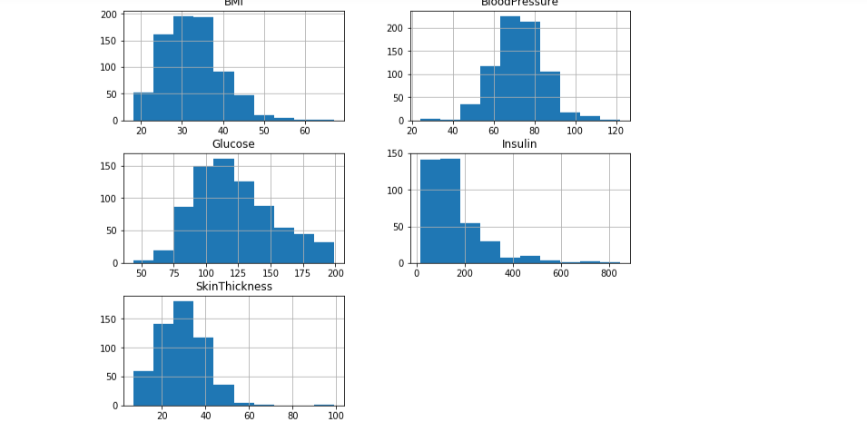
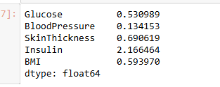
Based on the skew results and diagrams illustrating the (a)symmetry of these columns, the following filling decisions were adopted:
BloodPessure (0.13) and Glucose (0.53) >> approximately symmetric >> mean SkinThickness (0.69) and BMI (0.60) >> slightly asymmetric >> median Insulin (2.17) >> evidently asymetric >> median
Note: Skew values of -0.5 to 0.5 indicates approximate symmetry while <-1.0 or > 1.0 indicates high asymmetry/skewness
The median is chosen in case of asymmetry because filing with the mean would pull averages towards outliers or the direction of asymmetry. The mean would be a good approximation for missing values in the case of asymmetry.

Limitation: Median was imputed to 374 rows (about 49%) of insulin records. While this preserves the central tendency, it compresses the interquartile range and may affect the models variance.
The model was first trained on LogisticRegression with max_iter = 1000 and without scaling. Afterwards the model was scaled and tuned.
No improvement in accuracy score (0.7532) was observed after both scaling. This would mean that the unscaled model was still able to converge given the high iteration cap.
The test accuracy of the tuned and scaled model matched exactly to the baseline model (0.7532). This is because the best parameters selected by GridSearchCV matched the default hyperparameters as used in the baseline model.

C = 1 was the default regularisation and was selected GridSearchCV.

Bias/Variance
C is a parameter that determines regularisation strength. Larger C value means weaker regularisation, which also leads to high variance and low bias, hence more risk of overfitting. Smaller C values means stronger regularisation, which may also lead to low variance, high bias and hence, underfitting risk.
Larger values mean the model is less penalised for big weights on some features while with smaller C values, heavy weighted features are more penalised.
Bias measures error from oversimplification while variance measures errors from high sensitivity to training data.
Bias/variance tradeoff refers to the balance necessary between both states for the model to be optimally fitted.
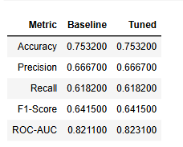
In conclusion, scaling and tuning did not improve the Logistic Regression model’s accuracy, precision, recall, or F1 score, as GridSearchCV selected the default regularisation parameter (C = 1). The only observed change was a very small increase.

